

Experiment No 08: Implementation of Doubly Linked List.

Aim: To implement doubly linked list.
Objectives :
- Implement a doubly linked list data structure in a programming language of choice.
- Implement basic operations on the doubly linked list, including insertion, deletion, traversal, and searching.
- Analyze the time and space complexity of these operations to understand the efficiency of the data structure.
- Explore real-world applications where doubly linked lists are useful and efficient.
Theory :
A doubly linked list is a fundamental data structure used in computer science and software engineering. It consists of a sequence of elements, each containing a data field and two links, one pointing to the previous element and the other to the next element. The purpose of this experiment is to implement a doubly linked list and analyze its operations, performance, and applications.

Algorithm :
# Node class to represent individual elements in the doubly linked list
class Node:
def __init__(self, data):
self.data = data
self.next = None # Reference to the next node
self.prev = None # Reference to the previous node

# DoublyLinkedList class to manage the list
class DoublyLinkedList:
def __init__(self):
self.head = None # Reference to the first node
self.tail = None # Reference to the last node

# Function to insert a new element at the beginning of the list
def insert_at_beginning(self, data):
new_node = Node(data)
if self.head is None:
self.head = self.tail = new_node
else:
new_node.next = self.head
self.head.prev = new_node
self.head = new_node

# Function to insert a new element at the end of the list
def insert_at_end(self, data):
new_node = Node(data)
if self.head is None:
self.head = self.tail = new_node
else:
new_node.prev = self.tail
self.tail.next = new_node
self.tail = new_node

# Function to delete a node with a specific data value
def delete(self, data):
current = self.head
while current:
if current.data == data:
if current.prev:
current.prev.next = current.next
else:
self.head = current.next

if current.next:
current.next.prev = current.prev
else:
self.tail = current.prev

return # Node found and deleted
current = current.next

# Function to traverse and print the list forwards
def traverse_forward(self):
current = self.head
while current:
print(current.data, end=" <-> ")
current = current.next
print("None")

# Function to traverse and print the list backwards
def traverse_backward(self):
current = self.tail
while current:
print(current.data, end=" <-> ")
current = current.prev
print("None")

# Example usage:
dllist = DoublyLinkedList()
dllist.insert_at_end(1)
dllist.insert_at_end(2)
dllist.insert_at_end(3)
dllist.insert_at_beginning(0)

dllist.traverse_forward() # Output: 0 <-> 1 <-> 2 <-> 3 <-> None
dllist.traverse_backward() # Output: 3 <-> 2 <-> 1 <-> 0 <-> None

dllist.delete(2)
dllist.traverse_forward() # Output: 0 <-> 1 <-> 3 <-> None

Code :
#include<stdio.h>
#include<conio.h>
#include<stdlib.h>
struct node
{
struct node *prev;
struct node *next;
int data;
};
struct node *head;
void insertion();

void deletion();

void display();

void main ()
{
int choice =0;
clrscr();
while(choice != 9)
{
printf("\n*********Main Menu*********\n");
printf("\nChoose one option from the following list ...\n");
printf("\n===============================================\n");
printf("\n1.Insert \n2.Delete \n3.display\n4.Exit\n");
printf("\nEnter your choice?\n");
scanf("\n%d",&choice);
switch(choice)
{
case 1:
insertion();
break;
case 2:
deletion();
break;
case 3:
display();
break;
case 4:
exit(0);
break;
default:
printf("Please enter valid choice..");
}
}
getch();
}
void insertion()
{
struct node *ptr,*temp;
int item;
ptr = (struct node *)malloc(sizeof(struct node));
if(ptr == NULL)
{
printf("\nOVERFLOW");
}
else
{
printf("\nEnter Item value");
scanf("%d",&item);
ptr->data=item;
if(head==NULL)
{
head = ptr;
ptr -> next = head;
ptr -> prev = head;
}
else
{
temp = head;
while(temp -> next != head)
{
temp = temp -> next;
}
temp -> next = ptr;
ptr -> prev = temp;
head -> prev = ptr;
ptr -> next = head;
head = ptr;
}
printf("\nNode inserted\n");
}

}

void deletion()
{
struct node *temp;
if(head == NULL)
{
printf("\n UNDERFLOW");
}
else if(head->next == head)
{
head = NULL;
free(head);
printf("\nnode deleted\n");
}
else
{
temp = head;
while(temp -> next != head)
{
temp = temp -> next;
}
temp -> next = head -> next;
head -> next -> prev = temp;
free(head);
head = temp -> next;
}

}
void display()
{
struct node *ptr;
ptr=head;
if(head == NULL)
{
printf("\nnothing to print");
}
else
{
printf("\n printing values ... \n");

while(ptr -> next != head)
{

printf("%d\n", ptr -> data);
ptr = ptr -> next;
}
printf("%d\n", ptr -> data);
}

}

Output :
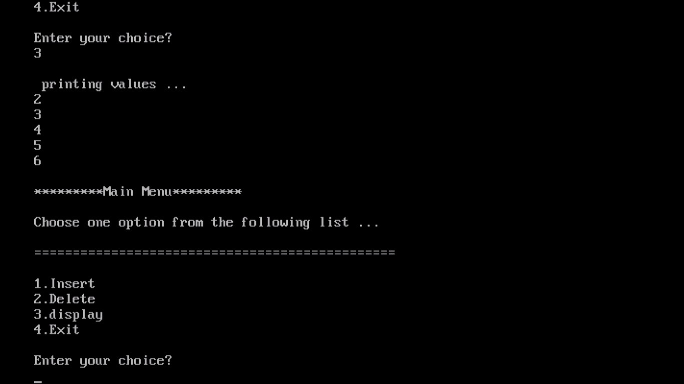

Conclusion :
Understanding the theory behind the implementation of a doubly linked list is crucial for building efficient and versatile data structures. By implementing and analyzing the operations of a doubly linked list, this experiment provides valuable insights into the practical aspects of this data structure and its applications in real-world scenarios.

